the MONTH IN REVIEW

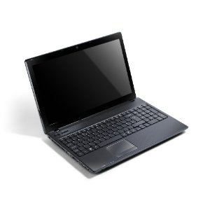
GRANDPA MAKES HIS MOVE:

Acer Aspire 5742z
WHY?
- desktop substitute
- 10-key pad for numbers
- 4-pound base to hold screen up
- holes all around it for I/O of stuff
- delivered & warrantied by a local “small box” company, dejunkified, avg free installed
- controls for dual monitors
Attacking Android: Patent Wars

Aug’10: Oracle sues Google
Over Android’s use of Java,
the Game:
A sues B
B finds where A infringes on a patent
Cross-licensing deals are worked out
The AMMUNITION

*Mobile patent inventories
(awarded + applied for):

RIM 3,134 MSFT 2,594
APPLE 477 ORACLE JAVA
GOOGLE 317
What’s happening

Google loses in bid for 6,000 Nortel patents
Won by consortium of APL, MSFT, Oracle, others
Google buys 1,000 patents from IBM

Oracle, MSFT seeking $10 to $20 license fee for each handset from mfrs using Android OS
ANDROID

Android most widely used smartphone OS in US
135 million users worldwide

Google gives Android free to device makers
Gets c. $10 in search fees from each device

Reform the Patent System?

“Everyone wants to”
Some are scared by the Courts

US Supreme Court rules:
You can’t patent a mathematical algorhythm

Aren’t all programs mathematical?
Could they be ruled unpatentable?
Firefox to the rescue

AVG blocks IE9 on Win7 from opening Yahoo page: “Script error”

Using newly updated Firefox runs beautifully

Tribune Community page (cont’d)

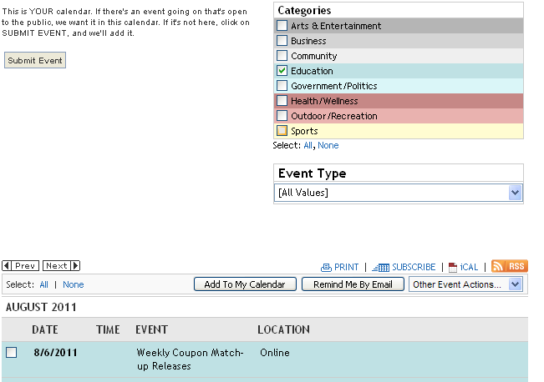

. . .and. . . 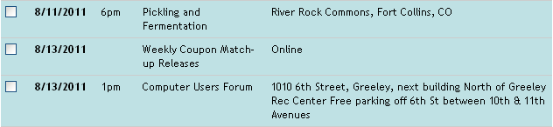
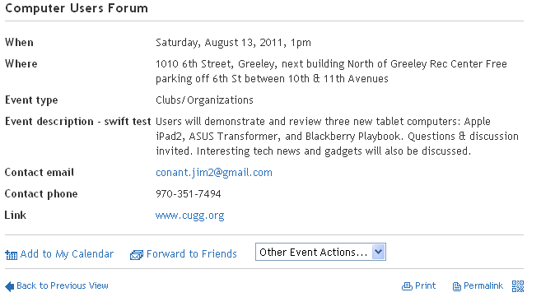
CUGG ON FACEBOOK
Nanotargeted Facebook ad

Facebook ad targeting: select options
Age: 31
Marital status: M
Gender: F
Employer: Likeable Media
Residence: NYC

Ad copy:

“Carrie I love you & miss you. I’ll be home soon.”

Likeable Media, by DaveKerpen
Apple announces MacBook Air
Replaces MacBook; keeps MacBook Pro
Lion OS; Core i5 or i7 procesor
Thunderbolt port; backlit keyboard
2.38 lbs (11”) or 3 lbs. (13”)
Battery lasts 5 to 7 hours on wireless web $999 up
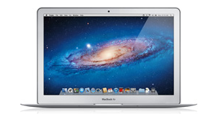
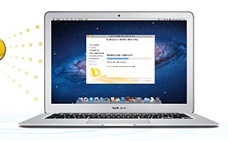
HP TOUCHPAD CUTS PRICES
-Cuts $100 to $400 & $500
for 16 GB & 32 GB
-800 TouchPad apps
-9,000 Web OS apps
-250,000 Android apps
-500,000 Apple apps
-iPad to get 61% market 2011
Limiting bandwidth hogs
AT&T will limit speeds for 5% of its customers
Streaming video & games
On its cellular networks; not on wi-fi
Those with unlimited data smartphone plans
Will charge for extra use, Oct. 1

T-Mobile already slows users over their limits

Verizon stopped signing up unlimited users
Robot reasons, learns from other robots

Carbonite bringing call center operations back from India to its Boston call site.
Post-call surveys:
Much better results in Boston
More customer referrals.

Carbonite has over 1 million users.
Google had 1.8 billion unique users in May, 2011.

Microsoft: 805 million
Facebook 714 million
Yahoo 689 million

Facebook leads in minutes spent at its site
(according to comScore)
Ron Wayne may write a book.
He’s the third Apple co-founder
Sold his 10% share of Apple for $800
To avoid the stress and liability for loans.

10% is now worth $22 billion.
AOL may terminate free-lance writers
Purchased HuffPo in February, 2011
Use more free bloggers, as HuffPo does
MySpace sold
News Corp hd bought it for $580 million
Sold it for $35 million to California ad agency

Focused as showplace for musicians and artists
Broadcast capabilities, “hubs”
Facebook partnered with Skype.
Users video chat with friends and family.
Hamster Free eBook Converter

- Use your e-books with more than 200 gadgets
- ebook.hamstersoft.com
Shrek virus

Let 30,000 ugly people into BeautifulPeople.com.

BeautifulPeople discovered it last month
Rejected them en-masse.

the Secret Life of the Grown-up Brain, by Barbara Strauch

We can generate “Cognitive reserve”
New neurons
Bilateral use
Frontal lobes used more
Keep us out of “Default mode”
What’s Good for brains
Aerobic Exercise
Blueberries
Caloric restriction
Mental exercise
“Brain Fitness” by Posit Science
Interaction with people
New mental activities
Write with non-dominant hand
Paint artwork (accountants)
Create Spreadsheets (artists)
Remote controlled model airplane

Camera in plane’s nose broadcasts images
To the user’s virtual reality goggles
Puts the user in the virtual cockpit.

Air & Space Magazine, published by Smithsonian

