How many of you have a video cameras, digital or analog?

How many of you would like to have videoed something you saw while traveling, or an accident you witnessed. Now as a witness you have to recall all the events to assist one of the accident participants?

Having a camera that recorded all the event might be of great assistance.

There are many different models of car mounted video cameras available in the market today. You just need to choose which one you prefer. Your decision may be because you like the size, the resolution capability, the FRAMES-PER-SECOND it can capture the video in, or several other factors.

Today I want to introduce you to this technology. Keep in mind the price will vary depending on what you choose and all its bells and whistles.

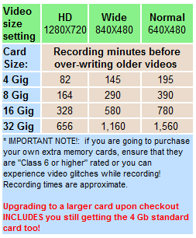IF you have been comparison shopping, the key things why you see so many differences in pricing are these:  
A.  Does it record in High-Def?   
B.  Does it have an HDMI hi-def video output jack?  
C.  Does it have the Zoran chipset?  (highest quality HD picture)  
D.  Does it include any SD memory card?  
E.  Does the motion detect work up to 25 feet or just a couple of feet?  
F.  Does it include any USB output jack and cable?  
G,  Does it have an RCA output jack and Video TV cables included?  
H.  Does it include free phone tech support and a 90-day warranty?

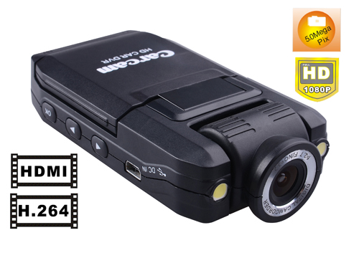

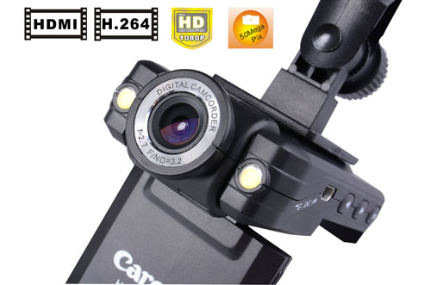

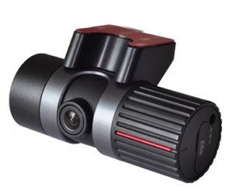

**SIV M9 Car Recorder Dual Cam 6 IR Camera Night Vision GPS**

**Special Price: $259.99**

**Description:**

Front/Rear Camera (120o View). 6 Infra-Red in Rear Camera. Easy Application Viewer, GPS Map Viewer...SIV M9 Dual Cam Driving Recorder records everything from the accident. Makes accident investigation process more precise.

[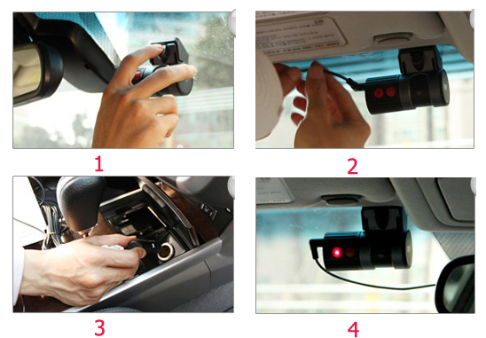](http://www.etronixmart.com/images/SIV-M9-Dual-Cam-Driving-Recorder-11)

Top of Form

**2-5. SIV Tracker by GPS (aka GPS Tracker)**

[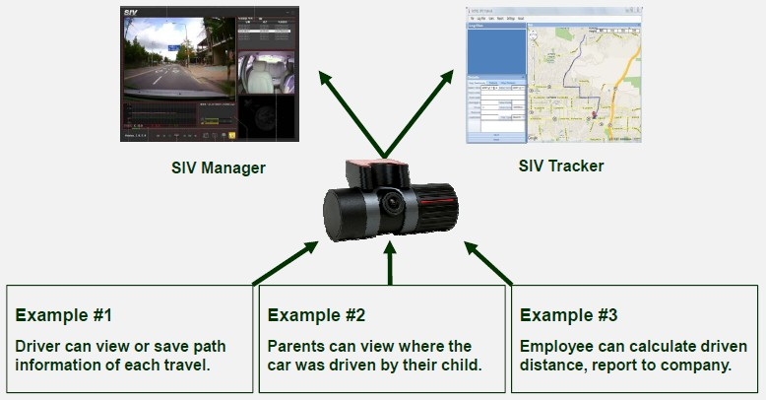](http://www.etronixmart.com/images/SIV-M9-Dual-Cam-Driving-Recorder-7)

### SIV Tracker (Additional S/W)

"SIV Tracker" provides maximized information to users (Car Driving Recorder + GPS Tracker). Not only can view the vehicle tracking but it also gives detailed information of trip.

[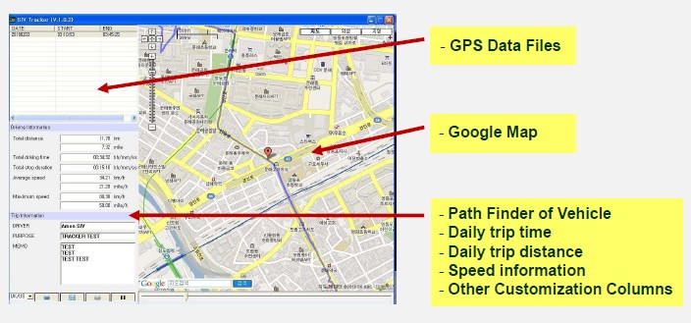](http://www.etronixmart.com/images/SIV-M9-Dual-Cam-Driving-Recorder-8)

### Features:

* 2 Channels Driving Recorder (Front & Inside)
* Advanced H.264 Video Recording Algorithm
* 640 x 480 VGA Resolution
* 16fps (Front Cam) / 8fps (Internal Cam)
* 0.3M Pixel Rotation Camera Lens (Main / Driver)
* 6 Intra Red (IR) for driver side camera
* Wide angle camera : 64.8"(V) x 92.8"(H) x 120"(D)
* 4GB / 8GB Micro SD Memory
* Plug-in Record, Plug-out Backup with Micro-SD
* 3 Axis G-Sensor Embedded
* Emergency Recording by Manual
* Privacy Mode (Mic On/Off) by external button
* Privacy Mode (Internal Camera On/Off) by external button
* Internal Microphone & Speaker
* Cigarette power adaptor
* Internal GPS Signal Receiver
* Google Map Support

Bottom of Form

|  |  |  |  |  |  |  |  |  |  |  |  |  |  |  |  |  |  |  |  |
| --- | --- | --- | --- | --- | --- | --- | --- | --- | --- | --- | --- | --- | --- | --- | --- | --- | --- | --- | --- |
| |  |  |  |  |  |  |  |  |  |  |  |  |  |  |  |  |  |  | | --- | --- | --- | --- | --- | --- | --- | --- | --- | --- | --- | --- | --- | --- | --- | --- | --- | --- | | **3.High Quality Motion Pictures(640x480) at Day/Night Time** http://www.safetybasement.com/v/vspfiles/photos/STR-CC100-5.jpg  **4. 6 IR Lamps Built In Rear View Camera Capture Objects in The Zero Lux  Darkness.** http://www.safetybasement.com/v/vspfiles/photos/STR-CC100-6.jpg   **5. 120 degrees Wide Camera Angle of Front View/ Rear View Camera.**  http://www.safetybasement.com/v/vspfiles/photos/STR-CC100-7.jpg   **6. Built-In GPS Module and Google Mapping**  **6-1. On Viewer Program** GPS Information on Google Map together with video footage on Viewer Program. http://www.safetybasement.com/v/vspfiles/photos/STR-CC100-8.jpg  **6-2. On GPS Tracking Program**  CCam Tracking Program loads GPS data and shows various driving information via Google Map  including driving path, driving distance and speed information. http://www.safetybasement.com/v/vspfiles/photos/STR-CC100-9.jpg  **7. Built-In 3D G-Sensor Triggers Event Recording.** The G-Sensor value graph synchronized with video footage on Viewer Program. Shocks, sudden acceleration whichever effects 3 dimension(X,Y,Z axes) directions of built-in G Sensor makes it trigger Event Recording( 3 level sensitivity). http://www.safetybasement.com/v/vspfiles/photos/STR-CC100-17.jpg  **8. Continuous Power Supply From Cigar Jack Cable.** http://www.safetybasement.com/v/vspfiles/photos/STR-CC100-10.jpg   **9. Easy Spot Playback On Navigator, IPhone/IPad and Laptop With Convenient Micro SD Card**. http://www.safetybasement.com/v/vspfiles/photos/STR-CC100-11.jpg  **10.Convenient Voice Guidance** http://www.safetybasement.com/v/vspfiles/photos/STR-CC100-12.jpg  **11. Various Recording Modes**   |  |  |  | | --- | --- | --- | | Normal recording | Voice ON | | | Voice OFF | | | Event recording | G-Sensor Trigger | Voice ON | | Voice OFF | | Manual | Voice ON | | Voice OFF | | Parking recording | Voice ON | | | Voice OFF | |   **12. Convertible to Indoor Surveillance Camera with optional AC Adapter** http://www.safetybasement.com/v/vspfiles/photos/STR-CC100-13.jpg  **13. Multi Voltage**  CCam can be installed in all vehicles with free-voltage feature (DC12V-24V).  **14. Print Out**  - Allows printing JPEG images of an accident file by PC software. - Print out GPS and Speed data with Year/month/day/time included.  **15. Lightweight, Tiny and Cute Design** http://www.safetybasement.com/v/vspfiles/photos/STR-CC100-14.jpg  **16. Specification** http://www.safetybasement.com/v/vspfiles/photos/STR-CC100-16.jpg  **17.Standard Package** http://www.safetybasement.com/v/vspfiles/photos/STR-CC100-15.jpg  **LOWELL’s CAMERA** | | http://www.safetybasement.com/v/vspfiles/templates/safetybase/images/clear1x1.gif |

[**http://www.dieselboss.com/camera/car_truck_rv_camera_dvr_hd1.htm**](http://www.dieselboss.com/camera/car_truck_rv_camera_dvr_hd1.htm)

**In-Vehicle "Black Box" camera / video DVR recording systems**

http://www.dieselboss.com/images/redbu2.jpgStop road fraud by having PROOF that you were right! http://www.dieselboss.com/images/redbu2.jpgRecord and share your travels http://www.dieselboss.com/images/redbu2.jpgCapture bizarre events on video

**Model DB3 -** Video / Audio  / Motion recording windshield style / USB, HDMI, and RCA outputs

**Description, usage, and usage features:**

* **High Resolution 720P** (1280 x 720) video and audio recording (30 fps) 120° width view and H.264 compression.  Can also be set to smaller video sizes to extend recording times.  SEE CHART AT BOTTOM-RIGHT OF THIS PAGE FOR RECORDING TIMES
* **Three video size modes:**  1280 x 720 (HD) ,  or 840 X 480 widescreen, or 640 X 480 standard
* 2.5" color TFT flip-down **video screen built-in**
* **Three choices for the length of each video** (2 mins, 5 mins, or 15 mins each.)  Or you can choose "continuous mode" and let it record one continuous movie.
* **Time and date** are stamped on the video itself.
* **Recording starts automatically** when you turn on power to the vehicle (12V socket) and turns off when you remove power unless you plug it into an "always on" socket in your rig.
* **"Motion Detection" mode** lets you set it to only record when motion is occurring in front of it.  Motion detection can detect up to 25 feet in front of it!  (10 times further than most competing cameras)
* Records on an **SD memory card** (4GB card included, expandable up to 32GB.)  The amount of video on the card before it starts to over-write old videos depends on the size of the card and the video size setting that you chose.  (see chart at lower-right on this page)
* Built-in **rechargeable battery** allows for up to about 45 minutes of recording without the unit being plugged in.  So it can be pulled from the windshield and used to walk around the rig during inspections or to take video and/or still pictures during a road event that has occurred.
* **Play back videos** (.avi format) on the attached screen, on a computer, or play them on any screen or TV that has an RCA or HDMI video input.  RCA video cable included!
* Use the **included USB cable** to transfer movies to a computer, or pop out the memory card and put it into any SD card capable laptop or computer.  Videos can be saved to a computer and played with any standard video software (Windows Media Player, VLC Player, etc.)
* **HDMI** output to connect to TV's or computers with an HDMI input.  (HDMI cable NOT included)
* **Suction style mounting** for easy removal and relocation.
* <http://www.youtube.com/v/Wh--qZS5cVc?version=3&amp;hl=en_US>

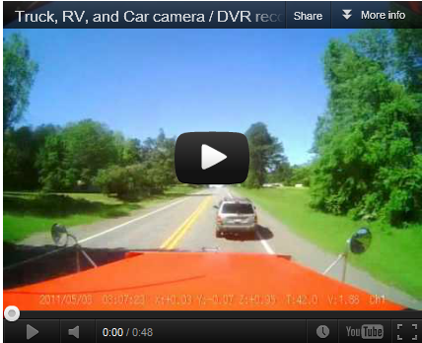(special thanks to driver Steve Kalko for this video) **What's included (per system)**http://www.dieselboss.com/images/black-dot.gif  **One HD drive camera / DVR black box all-in-one system**[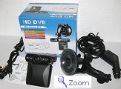](http://www.dieselboss.com/camera/db3_trucker_widshield_camera.jpg) (with Zoran HD chipset)  
http://www.dieselboss.com/images/black-dot.gif  One rechargeable battery pack (built in)  
http://www.dieselboss.com/images/black-dot.gif  12V power cable with lighter plug (12 feet extra long!)  
http://www.dieselboss.com/images/black-dot.gif  4Gb SD memory card (class 6)  
http://www.dieselboss.com/images/black-dot.gif  USB cable to connect to computer for retrieving video files  
http://www.dieselboss.com/images/black-dot.gif  RCA video/audio wire to connect to TV or monitor  
http://www.dieselboss.com/images/black-dot.gif  Suction-cup style adjustable, rotatable mount  
http://www.dieselboss.com/images/black-dot.gif  User guide  
http://www.dieselboss.com/images/black-dot.gif  90-day warranty against manufacturing defects

<http://www.wolfcomusa.com/Video/Videos.html>

|  |  |  |  |  |  |  |  |  |
| --- | --- | --- | --- | --- | --- | --- | --- | --- |
| http://www.wolfcomusa.com/images/3rdeye3.jpg | | | | | | | |  |
| [Wolfcom AV Recorder](http://www.signalone.com.au/content_common/pc-wolfcom-camera.seo) | » | [Wolfcom 3rd Eye HD Video Recorder](http://www.signalone.com.au/content_common/pc-wolfcom-3rd-eye-hd-video-recorder.seo) | » | [Wolfcom 3rd Eye HD AV Recorder](http://www.signalone.com.au/content_common/pr-wolfcom-3rd-eye-hd-video-recorder_wolfcom-av-recorder.seo) |  |

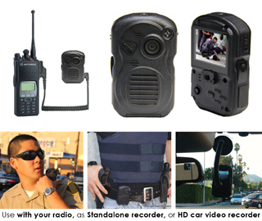

Wolfcom 3rd Eye HD AV Recorder

Code

BZW03

Wolfcom 3rd Eye High Definition 1080p AV Recorder - A product you can't afford to be without. Protecting Officers AND Civilians.

Price

$899.95

|  |  |  |  |  |  |  |  |
| --- | --- | --- | --- | --- | --- | --- | --- |
| [https://images-na.ssl-images-amazon.com/images/G/01/traffic/tea/amazon-logo-small._V187266497_.gif](http://www.amazon.com/gp/r.html?R=233XHST64FOTP&C=2CPFYBBWKUCAI&H=B4MZAQDIB87MGY9RFBNKTWTF5M0A&T=C&U=http%3A%2F%2Fwww.amazon.com%2Fref%3Dpe_56910_24090780_pe_vfe_logo) | |  | | --- | | E-mail or print for immediate delivery [**› Amazon.com Gift Cards**](http://www.amazon.com/gp/r.html?R=233XHST64FOTP&C=2CPFYBBWKUCAI&H=T0AGNSZJIIL1BE7LQ6FCXL5ULAOA&T=C&U=http%3A%2F%2Fwww.amazon.com%2Fgp%2Fgc%2Fref%3Dpe_56910_24090780_pe_vfe_promo) |  |  |  |  |  |  | | --- | --- | --- | --- | --- | | https://images-na.ssl-images-amazon.com/images/G/01/traffic/tea/p1._V187256488_.gif | [Your Amazon.com](http://www.amazon.com/gp/r.html?R=233XHST64FOTP&C=2CPFYBBWKUCAI&H=OLXL5EMUTNZ6TDCLGPBQQWAJVDYA&T=C&U=http%3A%2F%2Fwww.amazon.com%2Fgp%2Fyourstore%2Fhome%2Fref%3Dpe_56910_24090780_pe_vfe_tab1) | [Today's Deals](http://www.amazon.com/gp/r.html?R=233XHST64FOTP&C=2CPFYBBWKUCAI&H=TY4YSSYGH306M0OEFTJBJZKAYZCA&T=C&U=http%3A%2F%2Fwww.amazon.com%2Fgp%2Fgoldbox%2Fref%3Dpe_56910_24090780_pe_vfe_tab2) | [See All Departments](http://www.amazon.com/gp/r.html?R=233XHST64FOTP&C=2CPFYBBWKUCAI&H=K6GYABMNDYWX6J0W8HF5WWXCZESA&T=C&U=http%3A%2F%2Fwww.amazon.com%2Fgp%2Fsite-directory%2Fref%3Dpe_56910_24090780_pe_vfe_tab3) | https://images-na.ssl-images-amazon.com/images/G/01/traffic/tea/p3._V187256489_.gif | |
|  | |

|  |
| --- |
| Lowell Shatraw,  Are you looking for something in our Vehicle Back-up Cameras department? If so, you might be interested in these items. |

|  |  |  |  |  |  |  |  |  |
| --- | --- | --- | --- | --- | --- | --- | --- | --- |
| |  |  |  |  |  | | --- | --- | --- | --- | --- | | [2.5" HD Car LED IR Vehicle DVR Road Dash Video Camera Recorder Traffic Dashboard Camcorder - LCD 270° whirl](http://www.amazon.com/gp/r.html?R=233XHST64FOTP&C=2CPFYBBWKUCAI&H=PJLDLAOLTWGGC29VEAPAMW6SSOCA&T=C&U=http%3A%2F%2Fwww.amazon.com%2Fdp%2FB0053DDNW6%2Fref%3Dpe_56910_24090780_pe_vfe_dp1) | [2.5" HD Car LED IR Vehicle DVR Road Dash Video Camera Recorder Traffic Dashboard Camcorder - LCD 270° whirl](http://www.amazon.com/gp/r.html?R=233XHST64FOTP&C=2CPFYBBWKUCAI&H=UPIMJ5I1VP7RVG9U7UAUULYLDRAA&T=C&U=http%3A%2F%2Fwww.amazon.com%2Fdp%2FB0053DDNW6%2Fref%3Dpe_56910_24090780_pe_vfe_dt1)  by Dowson   **List Price:** $79.99 **Price: $34.29**  **You Save:** $45.70 (57%)  Ships from and sold by [Yorktek LLC](http://www.amazon.com/gp/r.html?R=233XHST64FOTP&C=2CPFYBBWKUCAI&H=TQQUAE1WLIIU41EBXYAJZBXWU2AA&T=C&U=http%3A%2F%2Fwww.amazon.com%2Fgp%2Faag%2Fdetails%2Fref%3Dpe_56910_24090780_pe_vfe_mer%3Fie%3DUTF8%26seller%3DA1DAMQ52W36V04). | |  | | --- | | [Learn more](http://www.amazon.com/gp/r.html?R=233XHST64FOTP&C=2CPFYBBWKUCAI&H=XATHANIZCJMWJG5DYQTGHFZGCXGA&T=C&U=http%3A%2F%2Fwww.amazon.com%2Fdp%2FB0053DDNW6%2Fref%3Dpe_56910_24090780_pe_vfe_lm1) | | [Add to wishlist](http://www.amazon.com/gp/r.html?R=233XHST64FOTP&C=2CPFYBBWKUCAI&H=OMZ4VAGAWSXIBEIVYWFYOPJHCHEA&T=C&U=http%3A%2F%2Fwww.amazon.com%2Fgp%2Fitem-dispatch%2Fref%3Dpe_56910_24090780_pe_vfe_wl1%3F_encoding%3DUTF8%26asin.1%3DB0053DDNW6%26template-name%3Dstores%252Fdetail%26submit.add-to-registry.wishlist.y%3D1%26submit.add-to-registry.wishlist.x%3D1%26action%3Dadd-to-registry.wishlist) | | |  |  |  | |
| |  | | --- | |  | |
| |  |  |  |  |  | | --- | --- | --- | --- | --- | | [SainSpeed F198 Car Dash DVR With Night Vision, Microphone Built In, 2.5" Rotatable and Foldable TFT LCD Screen display](http://www.amazon.com/gp/r.html?R=233XHST64FOTP&C=2CPFYBBWKUCAI&H=VF77WFPSZBRBBAWP4Y175IYRQRMA&T=C&U=http%3A%2F%2Fwww.amazon.com%2Fdp%2FB004YHVNWO%2Fref%3Dpe_56910_24090780_pe_vfe_dp2) | [SainSpeed F198 Car Dash DVR With Night Vision, Microphone Built In, 2.5" Rotatable and Foldable TFT LCD Screen display](http://www.amazon.com/gp/r.html?R=233XHST64FOTP&C=2CPFYBBWKUCAI&H=LLTFFRHNZIAKVQXLNVGVXMOC4AKA&T=C&U=http%3A%2F%2Fwww.amazon.com%2Fdp%2FB004YHVNWO%2Fref%3Dpe_56910_24090780_pe_vfe_dt2)  by Sain Store   **List Price:** $79.99 **Price: $28.77**  **You Save:** $51.22 (64%)  Sold by [Amazing Tech Depot](http://www.amazon.com/gp/r.html?R=233XHST64FOTP&C=2CPFYBBWKUCAI&H=Y9AHWR8GG1DLGIDI4UJLOY1DSYIA&T=C&U=http%3A%2F%2Fwww.amazon.com%2Fgp%2Faag%2Fdetails%2Fref%3Dpe_56910_24090780_pe_vfe_mer%3Fie%3DUTF8%26seller%3DATBLZ9RTDXRBW) and [Fulfilled by Amazon](http://www.amazon.com/gp/r.html?R=233XHST64FOTP&C=2CPFYBBWKUCAI&H=VIMOAX4FL58P094GIOO20BE24GAA&T=C&U=http%3A%2F%2Fwww.amazon.com%2Fgp%2Fhelp%2Fcustomer%2Fdisplay%2Fref%3Dpe_56910_24090780_pe_vfe_ssof%3Fie%3DUTF8%26nodeId%3D106096011). | |  | | --- | | [Learn more](http://www.amazon.com/gp/r.html?R=233XHST64FOTP&C=2CPFYBBWKUCAI&H=KG3ERIJC0NKO6GABPVCUMTTUYZUA&T=C&U=http%3A%2F%2Fwww.amazon.com%2Fdp%2FB004YHVNWO%2Fref%3Dpe_56910_24090780_pe_vfe_lm2) | | [Add to wishlist](http://www.amazon.com/gp/r.html?R=233XHST64FOTP&C=2CPFYBBWKUCAI&H=UAK5SRSPW4EKBTKLCH9CXMMR2G4A&T=C&U=http%3A%2F%2Fwww.amazon.com%2Fgp%2Fitem-dispatch%2Fref%3Dpe_56910_24090780_pe_vfe_wl2%3F_encoding%3DUTF8%26asin.1%3DB004YHVNWO%26template-name%3Dstores%252Fdetail%26submit.add-to-registry.wishlist.y%3D1%26submit.add-to-registry.wishlist.x%3D1%26action%3Dadd-to-registry.wishlist) | | |  |  |  | |
| |  | | --- | |  | |
| |  |  |  |  |  | | --- | --- | --- | --- | --- | | [HD 720P 2.5" LCD Monitor CAR Dash Dashboard CAMERA Cam VEHICLE VIDEO Accident RECORDER DVR Support SD/MMC Memory Card : Up to 64GB](http://www.amazon.com/gp/r.html?R=233XHST64FOTP&C=2CPFYBBWKUCAI&H=5CU5HIPX1E5F1S0ATGJKDU7AOWKA&T=C&U=http%3A%2F%2Fwww.amazon.com%2Fdp%2FB005680BX2%2Fref%3Dpe_56910_24090780_pe_vfe_dp3) | [HD 720P 2.5" LCD Monitor CAR Dash Dashboard CAMERA Cam VEHICLE VIDEO Accident RECORDER DVR Support SD/MMC Memory Card : Up to 64GB](http://www.amazon.com/gp/r.html?R=233XHST64FOTP&C=2CPFYBBWKUCAI&H=MRJBE88JVYJICAJ66M5VI8USG8YA&T=C&U=http%3A%2F%2Fwww.amazon.com%2Fdp%2FB005680BX2%2Fref%3Dpe_56910_24090780_pe_vfe_dt3)  by NWW   **Price: $37.98**  Sold by [CRONUZ](http://www.amazon.com/gp/r.html?R=233XHST64FOTP&C=2CPFYBBWKUCAI&H=WA75YKYSMFZZM4HAJESRMAW8WAWA&T=C&U=http%3A%2F%2Fwww.amazon.com%2Fgp%2Faag%2Fdetails%2Fref%3Dpe_56910_24090780_pe_vfe_mer%3Fie%3DUTF8%26seller%3DA2H7GTKX2B8S7Q) and [Fulfilled by Amazon](http://www.amazon.com/gp/r.html?R=233XHST64FOTP&C=2CPFYBBWKUCAI&H=VIMOAX4FL58P094GIOO20BE24GAA&T=C&U=http%3A%2F%2Fwww.amazon.com%2Fgp%2Fhelp%2Fcustomer%2Fdisplay%2Fref%3Dpe_56910_24090780_pe_vfe_ssof%3Fie%3DUTF8%26nodeId%3D106096011). | |  | | --- | | [Learn more](http://www.amazon.com/gp/r.html?R=233XHST64FOTP&C=2CPFYBBWKUCAI&H=LCPVFOOCNAKGY8YR1UVKITAYBWSA&T=C&U=http%3A%2F%2Fwww.amazon.com%2Fdp%2FB005680BX2%2Fref%3Dpe_56910_24090780_pe_vfe_lm3) | | [Add to wishlist](http://www.amazon.com/gp/r.html?R=233XHST64FOTP&C=2CPFYBBWKUCAI&H=XGDOLXVUFOJZKX2KYYOJY3FAVZQA&T=C&U=http%3A%2F%2Fwww.amazon.com%2Fgp%2Fitem-dispatch%2Fref%3Dpe_56910_24090780_pe_vfe_wl3%3F_encoding%3DUTF8%26asin.1%3DB005680BX2%26template-name%3Dstores%252Fdetail%26submit.add-to-registry.wishlist.y%3D1%26submit.add-to-registry.wishlist.x%3D1%26action%3Dadd-to-registry.wishlist) | | |  |  |  | |
| |  | | --- | |  | |
| |  |  |  |  |  | | --- | --- | --- | --- | --- | | [HD Car Dashboard Camera Car Accident DVR with LCD and 140 degree wide angle lense IR NIght Vision](http://www.amazon.com/gp/r.html?R=233XHST64FOTP&C=2CPFYBBWKUCAI&H=ZKK8IABJSTCZXFEZAMOQY1FS0VQA&T=C&U=http%3A%2F%2Fwww.amazon.com%2Fdp%2FB00567H67C%2Fref%3Dpe_56910_24090780_pe_vfe_dp4) | [HD Car Dashboard Camera Car Accident DVR with LCD and 140 degree wide angle lens IR Night Vision](http://www.amazon.com/gp/r.html?R=233XHST64FOTP&C=2CPFYBBWKUCAI&H=JRFZXZGJNZNGKUIODZTMCO0ABAAA&T=C&U=http%3A%2F%2Fwww.amazon.com%2Fdp%2FB00567H67C%2Fref%3Dpe_56910_24090780_pe_vfe_dt4)  by VisionTek   **List Price:** $99.99 **Price: $34.78**  **You Save:** $65.21 (65%)  Sold by [Bestgoodlikewater](http://www.amazon.com/gp/r.html?R=233XHST64FOTP&C=2CPFYBBWKUCAI&H=BXJBPXV3ORODRC48OVA3PBA3ZJSA&T=C&U=http%3A%2F%2Fwww.amazon.com%2Fgp%2Faag%2Fdetails%2Fref%3Dpe_56910_24090780_pe_vfe_mer%3Fie%3DUTF8%26seller%3DAD8KB6G20MIR8) and [Fulfilled by Amazon](http://www.amazon.com/gp/r.html?R=233XHST64FOTP&C=2CPFYBBWKUCAI&H=VIMOAX4FL58P094GIOO20BE24GAA&T=C&U=http%3A%2F%2Fwww.amazon.com%2Fgp%2Fhelp%2Fcustomer%2Fdisplay%2Fref%3Dpe_56910_24090780_pe_vfe_ssof%3Fie%3DUTF8%26nodeId%3D106096011). | |  | | --- | | [Learn more](http://www.amazon.com/gp/r.html?R=233XHST64FOTP&C=2CPFYBBWKUCAI&H=AY1STRF5UL5UCY7PNZE2URLXR9QA&T=C&U=http%3A%2F%2Fwww.amazon.com%2Fdp%2FB00567H67C%2Fref%3Dpe_56910_24090780_pe_vfe_lm4) | | [Add to wishlist](http://www.amazon.com/gp/r.html?R=233XHST64FOTP&C=2CPFYBBWKUCAI&H=ZEDTCZ7AN7GKRLVRUNSBLIGXR1AA&T=C&U=http%3A%2F%2Fwww.amazon.com%2Fgp%2Fitem-dispatch%2Fref%3Dpe_56910_24090780_pe_vfe_wl4%3F_encoding%3DUTF8%26asin.1%3DB00567H67C%26template-name%3Dstores%252Fdetail%26submit.add-to-registry.wishlist.y%3D1%26submit.add-to-registry.wishlist.x%3D1%26action%3Dadd-to-registry.wishlist) | | |  |  |  | |
| |  | | --- | |  | |
| |  |  |  |  |  | | --- | --- | --- | --- | --- | | [Car DVR Camera Camcorder Recorder w/ 4 LED IR Night Vision and 2.5" LCD](http://www.amazon.com/gp/r.html?R=233XHST64FOTP&C=2CPFYBBWKUCAI&H=ICIMGWIHLTNNMHQLQNOGV7R7LSUA&T=C&U=http%3A%2F%2Fwww.amazon.com%2Fdp%2FB005672HA8%2Fref%3Dpe_56910_24090780_pe_vfe_dp5) | [Car DVR Camera Camcorder Recorder w/ 4 LED IR Night Vision and 2.5" LCD](http://www.amazon.com/gp/r.html?R=233XHST64FOTP&C=2CPFYBBWKUCAI&H=D58BME7QAZADB00ANZRI1OFZAY4A&T=C&U=http%3A%2F%2Fwww.amazon.com%2Fdp%2FB005672HA8%2Fref%3Dpe_56910_24090780_pe_vfe_dt5)  by Elution   **Price: $29.99**  Ships from and sold by [HaoJetSo](http://www.amazon.com/gp/r.html?R=233XHST64FOTP&C=2CPFYBBWKUCAI&H=ADF86DNLDAQAUFLJANAX6OC9PKAA&T=C&U=http%3A%2F%2Fwww.amazon.com%2Fgp%2Faag%2Fdetails%2Fref%3Dpe_56910_24090780_pe_vfe_mer%3Fie%3DUTF8%26seller%3DA3S5V5QB32IO47). | |  | | --- | | [Learn more](http://www.amazon.com/gp/r.html?R=233XHST64FOTP&C=2CPFYBBWKUCAI&H=KMWMXII556XSEXZELYHTFJABGG4A&T=C&U=http%3A%2F%2Fwww.amazon.com%2Fdp%2FB005672HA8%2Fref%3Dpe_56910_24090780_pe_vfe_lm5) | | [Add to wishlist](http://www.amazon.com/gp/r.html?R=233XHST64FOTP&C=2CPFYBBWKUCAI&H=QZFXIBVAC2VQGPRGPY7SZXC9KG8A&T=C&U=http%3A%2F%2Fwww.amazon.com%2Fgp%2Fitem-dispatch%2Fref%3Dpe_56910_24090780_pe_vfe_wl5%3F_encoding%3DUTF8%26asin.1%3DB005672HA8%26template-name%3Dstores%252Fdetail%26submit.add-to-registry.wishlist.y%3D1%26submit.add-to-registry.wishlist.x%3D1%26action%3Dadd-to-registry.wishlist) | | |  |  |  | |
| |  | | --- | |  | |
| |  |  |  |  |  | | --- | --- | --- | --- | --- | | [Car Dashboard Video Camera Cam Accident DVR Full Hd Resolution , 2.0" Ltps TFT LCD Display](http://www.amazon.com/gp/r.html?R=233XHST64FOTP&C=2CPFYBBWKUCAI&H=NU9DE2MLYQHQVRGMSQP1NDX0ZNIA&T=C&U=http%3A%2F%2Fwww.amazon.com%2Fdp%2FB00622DUVG%2Fref%3Dpe_56910_24090780_pe_vfe_dp6) | [Car Dashboard Video Camera Cam Accident DVR Full Hd Resolution , 2.0" Ltps TFT LCD Display](http://www.amazon.com/gp/r.html?R=233XHST64FOTP&C=2CPFYBBWKUCAI&H=CUCGRPSHSR7JARPOQT9YHJLYXK4A&T=C&U=http%3A%2F%2Fwww.amazon.com%2Fdp%2FB00622DUVG%2Fref%3Dpe_56910_24090780_pe_vfe_dt6)  by Brainydeal   **List Price:** $79.99 **Price: $51.68**  **You Save:** $28.31 (35%)  Ships from and sold by [Yorktek LLC](http://www.amazon.com/gp/r.html?R=233XHST64FOTP&C=2CPFYBBWKUCAI&H=TQQUAE1WLIIU41EBXYAJZBXWU2AA&T=C&U=http%3A%2F%2Fwww.amazon.com%2Fgp%2Faag%2Fdetails%2Fref%3Dpe_56910_24090780_pe_vfe_mer%3Fie%3DUTF8%26seller%3DA1DAMQ52W36V04). | |  | | --- | | [Learn more](http://www.amazon.com/gp/r.html?R=233XHST64FOTP&C=2CPFYBBWKUCAI&H=Y76ERCPVY9HJWFUO5AQ9IFHTWZ0A&T=C&U=http%3A%2F%2Fwww.amazon.com%2Fdp%2FB00622DUVG%2Fref%3Dpe_56910_24090780_pe_vfe_lm6) | | [Add to wishlist](http://www.amazon.com/gp/r.html?R=233XHST64FOTP&C=2CPFYBBWKUCAI&H=FOUSDOT603ABMXADFWNQOTBVD4MA&T=C&U=http%3A%2F%2Fwww.amazon.com%2Fgp%2Fitem-dispatch%2Fref%3Dpe_56910_24090780_pe_vfe_wl6%3F_encoding%3DUTF8%26asin.1%3DB00622DUVG%26template-name%3Dstores%252Fdetail%26submit.add-to-registry.wishlist.y%3D1%26submit.add-to-registry.wishlist.x%3D1%26action%3Dadd-to-registry.wishlist) | | |  |  |  | |
| |  | | --- | |  | |
| |  |  |  |  |  | | --- | --- | --- | --- | --- | | [HD Car Video Camera Dual Lens LCD DVR Dash Recorder Black Box](http://www.amazon.com/gp/r.html?R=233XHST64FOTP&C=2CPFYBBWKUCAI&H=AJEU5SBJLDYRSADANQQKIUONYTAA&T=C&U=http%3A%2F%2Fwww.amazon.com%2Fdp%2FB004YSGRWY%2Fref%3Dpe_56910_24090780_pe_vfe_dp7) | [HD Car Video Camera Dual Lens LCD DVR Dash Recorder Black Box](http://www.amazon.com/gp/r.html?R=233XHST64FOTP&C=2CPFYBBWKUCAI&H=UA0PU1SDFKEOJQCGVWEPNGR9UJKA&T=C&U=http%3A%2F%2Fwww.amazon.com%2Fdp%2FB004YSGRWY%2Fref%3Dpe_56910_24090780_pe_vfe_dt7)  by Dowson   **List Price:** $179.99 **Price: $79.99**  **You Save:** $100.00 (56%)  Sold by [SuperSaver Deals](http://www.amazon.com/gp/r.html?R=233XHST64FOTP&C=2CPFYBBWKUCAI&H=GZJABAG91SMOKA8ATZAA0CJR5RAA&T=C&U=http%3A%2F%2Fwww.amazon.com%2Fgp%2Faag%2Fdetails%2Fref%3Dpe_56910_24090780_pe_vfe_mer%3Fie%3DUTF8%26seller%3DA32VV8QE6DM094) and [Fulfilled by Amazon](http://www.amazon.com/gp/r.html?R=233XHST64FOTP&C=2CPFYBBWKUCAI&H=VIMOAX4FL58P094GIOO20BE24GAA&T=C&U=http%3A%2F%2Fwww.amazon.com%2Fgp%2Fhelp%2Fcustomer%2Fdisplay%2Fref%3Dpe_56910_24090780_pe_vfe_ssof%3Fie%3DUTF8%26nodeId%3D106096011). | |  | | --- | | [Learn more](http://www.amazon.com/gp/r.html?R=233XHST64FOTP&C=2CPFYBBWKUCAI&H=O6UFXEUKSUWG0GNNLF4BH1EEPB8A&T=C&U=http%3A%2F%2Fwww.amazon.com%2Fdp%2FB004YSGRWY%2Fref%3Dpe_56910_24090780_pe_vfe_lm7) | | [Add to wishlist](http://www.amazon.com/gp/r.html?R=233XHST64FOTP&C=2CPFYBBWKUCAI&H=TTO7SYH56TTYUAZMHOFEH65YJAEA&T=C&U=http%3A%2F%2Fwww.amazon.com%2Fgp%2Fitem-dispatch%2Fref%3Dpe_56910_24090780_pe_vfe_wl7%3F_encoding%3DUTF8%26asin.1%3DB004YSGRWY%26template-name%3Dstores%252Fdetail%26submit.add-to-registry.wishlist.y%3D1%26submit.add-to-registry.wishlist.x%3D1%26action%3Dadd-to-registry.wishlist) | | |  |  |  | |

<http://www.etronixmart.com/hd-1080p-car-dashboard-camera-cam-night-vision-accident-dvr-p-875.html>

<http://www.etronixmart.com/siv-m9-car-recorder-dual-cam-6-ir-camera-night-vision-gps-p-824.html>

<http://www.brickhousesecurity.com/voyager-car-camera-gps-logger.html>

<http://www.10-8video.com/?gclid=CJPNu6CR7K8CFQkEQAodEFCaLg>

<http://www.nextag.com/car-video-camera/compare-html>

<http://www.northerntool.com/shop/tools/product_200395504_200395504?cm_mmc=Aggregates-_-Nextag-_-Farm> + Acreage>Tractor Accessories-_-119899

<http://www.tmart.com/20-HD-2x-Cameras-4-LED-Infrared-Night-Vision-Traffic-Recorder_p122110.html>

<http://www.tmart.com/Car-Camera-Recorders/>

<http://www.amazon.com/Recording-recording-G-Sensor-Definition-camera-Free/dp/B005J6MTY0>

<http://www.safetybasement.com/2-Ch-Car-recorder-with-GPS-Audio-night-vision-p/str-cc100.htm>

<http://www.etronixmart.com/siv-m9-car-recorder-dual-cam-6-ir-camera-night-vision-gps-p-824.html>

<http://www.wolfcomusa.com/Video/Videos.html>

<http://www.signalone.com.au/content_common/pr-wolfcom-3rd-eye-hd-video-recorder_wolfcom-av-recorder.seo>

<http://keytroller.com/SMARTIE-1-2-OR-3-Video-Drive-Camera-With-GPS.html?page=1>

<http://www.dieselboss.com/camera/car_truck_rv_camera_dvr_hd1.htm>

<http://www.aliexpress.com/store/803232/211338086-513207471/new-arrive-M9-car-black-box-car-video-recorder-with-GPS-track-record-gravity-protection-device.html>

<http://www.dailytech.com/First+Circuit+Court+of+Appeals+Rules+that+Citizens+Can+Videotape+Police/article22587.htm>

[First Circuit Court of Appeals Rules that Citizens Can Videotape Police](http://www.dailytech.com/First+Circuit+Court+of+Appeals+Rules+that+Citizens+Can+Videotape+Police/article22587.htm)  
[Tiffany Kaiser](http://www.dailytech.com/ContactStaff.aspx?id=145) - August 31, 2011 1:33 PM

|  |  |  |  |  |  |  |  |  |  |  |
| --- | --- | --- | --- | --- | --- | --- | --- | --- | --- | --- |
| [http://www.dailytech.com/i/print.gif](javascript:print();) | [Print](javascript:print();) |  | http://w.sharethis.com/images/hbutton.gif |  |  |  |  |  | [http://www.dailytech.com/i/talk.gif](http://www.dailytech.com/First+Circuit+Court+of+Appeals+Rules+that+Citizens+Can+Videotape+Police/article22587.htm#comments) | [**69** comment(s) - last by **espaghetti..** on **Sep 15** at **12:09 PM**](http://www.dailytech.com/First+Circuit+Court+of+Appeals+Rules+that+Citizens+Can+Videotape+Police/article22587.htm#cmt715329) |

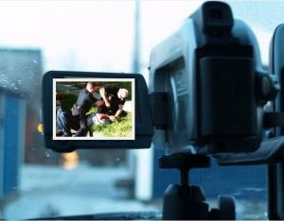

  (Source: mindseyenews.webs.com)

[http://static.sv.us.criteo.net/flash/icon/nai_small.png](http://info.criteo.com/pdf/privacy/informations?infonorm=2&partner=3463&campaignid=5747&zoneid=41327&bannerid=191827&displayid=4f08b6e204)

http://pixel.adsafeprotected.com?anId=68&pubId=dailytech/ros/300x250/jx/ss/a/L29&advId=&campId=USNetwork/BCN2011110862_001N_Criteo

http://dynamic1.dailytech.com/www/delivery/lg.php?bannerid=71&campaignid=44&zoneid=7&source=gadgets&loc=1&referer=http%3A%2F%2Fwww.dailytech.com%2FFirst+Circuit+Court+of+Appeals+Rules+that+Citizens+Can+Videotape+Police%2Farticle22587.htm&cb=79df013caf

The filming of government officials while on duty is protected by the First Amendment, said the Court  
  
The First Circuit Court of Appeals reached a crucial decision last Friday allowing the public to videotape police officers while they're on the clock.   
  
The decision comes after a string of incidents where individuals have videotaped police officers and were arrested. Police officers across the United States believed citizens didn't have the right to videotape them as they conducted official duties, but issues like police brutality put the issue up for debate.

<http://peacefreedomprosperity.com/5618/federal-court-rules-videotaping-police-is-a-first-amendment-right/>

**READ ALL OF THIS** <http://www.flexyourrights.org/7_Rules_for_Recording_Police/blog>

**Rule #1: Know the Law (Wherever You Are)**

Conceived at a time when pocket-sized recording devices were available only to James Bond types, most eavesdropping laws were originally intended to protect people against snoops, spies, and peeping Toms. Now with this technology in the hands of average citizens, police and prosecutors are abusing these outdated laws to punish citizens merely attempting to document on-duty police.

The [law in 38 states](http://www.rcfp.org/can-we-tape/introduction) plainly allows citizens to record police, as long as you don’t physically interfere with their work. Police might still unfairly harass you, detain you, or confiscate your camera. They might even arrest you for some catchall misdemeanor such as obstruction of justice or disorderly conduct. But you will not be charged for illegally recording police.

Twelve states—California, Connecticut, Florida, Illinois, Maryland, Massachusetts, Michigan, Montana, Nevada, New Hampshire, Pennsylvania, and Washington—require the consent of all parties for you to record a conversation.

However, all but 2 of these states—Massachusetts and Illinois—have an “expectation of privacy provision” to their all-party laws that courts have ruled does not apply to on-duty police (or anyone in public). In other words, it’s technically legal in those 48 states to openly record on-duty police.

**Rule #2 Don’t Secretly Record Police**

In most states it’s almost always illegal to record a conversation in which you’re not a party and don’t have consent to record. Massachusetts is the only state to uphold a conviction for recording on-duty police, but that conviction was for a [secret recording](http://www.rense.com/general11/fur.htm) where the defendant failed to inform police he was recording. (As in the Glik case, Massachusetts courts have ruled that openly recording police is legal, but secretly recording them isn’t.)

Fortunately, judges and juries are soundly rejecting these laws. Illinois, the state with the most notorious anti-recording laws in the land, expressly forbids you from recording on-duty police. Early last month an Illinois judge declared that law unconstitutional, ruling in favor of Chris Drew, a Chicago artist charged with felony eavesdropping for secretly recording his own arrest. Last August a jury acquitted Tiawanda Moore of secretly recording two Chicago Police Internal Affairs investigators who encouraged her to drop a sexual harassment complaint against another officer. (A juror described the case to a reporter as “a waste of time.”) In September, an Illinois state judge dropped felony charges against Michael Allison. After running afoul of local zoning ordinances, he faced up to 75 years in prison for secretly recording police and attempting to tape his own trial.

The lesson for you is this: If you want to limit your legal exposure and present a strong legal case, record police openly if possible. But if you videotape on-duty police from a distance, such an announcement might not be possible or appropriate unless police approach you.

**Rule #3: Respond to “Shit Cops Say”**

When it comes to police encounters, you don’t get to choose whom you’re dealing with. You might get [Officer Friendly](http://youtu.be/ZFzH5Oe-YL4), or you might get [Officer Psycho](http://gizmodo.com/5826912/berserk-cop-arrests-photographer-for-standing-on-sidewalk). You’ll likely get officers between these extremes. But when you “watch the watchmen,” you must be ready to think on your feet.

In most circumstances, officers will not immediately [bull rush you for filming them](http://youtu.be/QUk37Kq96KQ?t=10m9s). But if they aren’t properly trained, they might feel like their authority is being challenged. And all too often police are simply ignorant of the law. Part of your task will be to convince them that you’re not a threat while also standing your ground.