Texting
CUGG 7/14/12
Stan Sameshima

What is texting and how does it work?

A cell phone sends and receives a signal periodically to “check in” with the cell towers. When a text is sent, the message is included with information such as the destination, amount of data in the message, and a time stamp. It goes to the nearest tower and is then sent to a SMSC, and then to it’s destination.

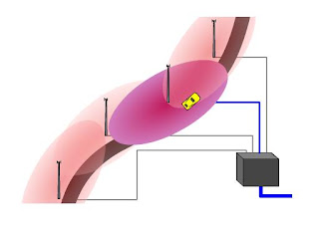

SMS =( short message service) Can be sent to phones, computers, PDAs (Personal Digital Assistants).
Short, because limited to 160 characters or letters
SMS goes to SMSC (short message service center) and may be stored for several days until the receiving phone is turned on or comes into range of a tower
http://www.ehow.com/how-does_4571898_text-messaging-work.html
http://computer.howstuffworks.com/e-mail-messaging/sms.htm

A common complaint about SMS is its inefficient delivery structure -- when the message center is backed up, messages take longer to reach their destination. To make message delivery faster, networks are using more new next-generation technologies such as GPRS (General Packet Radio Service).
EMS (Enhanced Messaging Service), you can send formatted text, sound effects, small pictures and icons
MMS (Multimedia Messaging Service) allows you to send animations, audio and video files in addition to text. However, the cost per message will be higher. MMS requires a 3G network and is capable of sending unlimited data including streaming video.
SMS messages may be sent using VoIP and Skype services or instant messaging services such as Yahoo, AOL (AIM), ICQ, or Windows Messenger.
Why- unobtrusive, private, no one can overhear
multitasking, available in all environments
For deaf or hearing-impaired
Could be faster for a short message
Could contain info that is stored on the receiving phone to refer to later (e.g. text me your name)
May be sent to multiple recipients
Doesn’t have to be answered immediately
A picture may be text-messaged (location, shopping, portrait, identify an item)
A video may be sent
A link
You can review what you are sending before you send it
(insert pic]
Television poll or other poll won’t overload a network or require voice operators

“You can use text messaging subscription services to get medication reminders sent to your phone, along with weather alerts, news headlines or even novels broken into 160-character "chapters." Internet search engines such as Yahoo! and Google have short messaging services that enable users to get information such as driving directions, movie showtimes or local business listings just by texting a query to the search engine's phone number. Social networking services such as Dodgeball use SMS to alert people who live in big cities when their friends or crushes are nearby. The possibilities for integrating SMS into your lifestyle seem endless. “
http://computer.howstuffworks.com/e-mail-messaging/sms1.htm

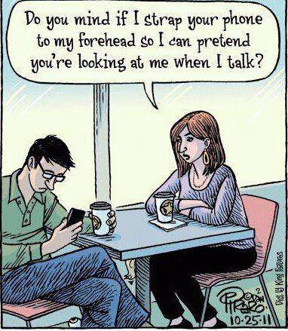

History

Text messages were offered within networks, but in 2003 phone companies figured out how to track and then how to charge for text messages crossing from one provider to another. Texting became possible in the U.S. and Canada. A text message cost 1/3 of one cent to transmit and companies charged 10 to 20 cents to the customer. A markup of 4,000%!

“In 2007 Apollo IM, an iPhone app allowed users to connect to AOL and other free instant-messaging networks via the Internet connection [source: Wilson]. In late 2008, San Jose-based Pinger rolled out an iPhone app called Pinger Phone, which enabled users to send text messages over the Internet to other phones, even if they weren't running the Pinger app [source: PR Newswire]. Others providers, with names like TextPlus, WhatsApp and Kik were quick to follow [source: Wortham].”
http://electronics.howstuffworks.com/cell-phone-apps/free-texting-apps-legal2.htm

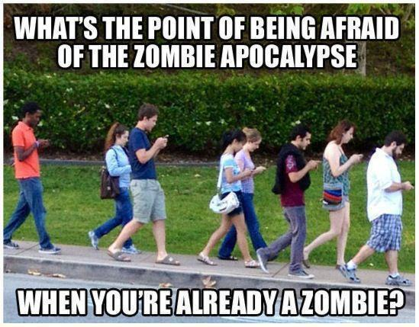

MSM messages can be sent via email:
http://www.ehow.com/how_2160755_send-text-message-cell-phone.html
Verizon phones can be messaged from a computer by going to a Verizon website or emailing Verizon:
http://www.ehow.com/how_2279421_send-verizon-wireless-customer-computer.html

AT&T is developing something called “Encore,” which will allow you access messages on iPhone, iPad, and computers
http://www.att.com/gen/press-room?pid=21023

Sprint offers a service that will send messages from your computer to the MSM Center to any phone
http://www.sprintusers.com/textmessage/

Google Play has an app that syncs your phone and your computer, but only works with Android phones
http://mightytext.net/
https://play.google.com/store/apps/details?id=com.verizon.messaging.vzmsgs&hl=en

iPhone users have iMessage for other Apple devices:
http://www.apple.com/ios/features.html

Happy Fingers app for iPhone for PCs:
http://www.happyfingersapp.com/

video of “WifiSMS” is harder to set up, but is more integrated:
http://www.youtube.com/watch?v=CRUy-1t7KEw

Email, Windows Messenger, AOL Instant Messaging (AIM), are all free

Facebook, twitter, tumblr, twitter, Google+, blogs are like messaging, but are designed to be viewed by the public

dictionaries, word lists
http://netforbeginners.about.com/od/internetglossary/tp/The-Top-Text-Message-Acronyms-of-2011.htm

http://www.webopedia.com/quick_ref/textmessageabbreviations.asp/

