Creating PDF Files
Ron Mettler December 14, 2006

Earlier this year at a monthly CUGG meeting, I reviewed Adobe Acrobat PDF maker. Since then two products have been introduced that provide a means of producing PDF files similar to the Adobe product. “PDF Converter Professional 4” by Nuance is a full featured business product that appears to provide all of the features of Adobe Acrobat a much lower cost. The product will create PDF files from any Windows application. The ability to create PDF fill-in forms, text-to-speech conversion features, and on-line collaboration capabilities are advanced items that businesses may need. The product retails for $99.99 and can be purchased locally or on-line from the manufacturer at http://www.nuance.com/pdfconverter/professional/. The comparable product from Adobe is “Adobe Acrobat Professional 8.0” at a cost of $449.

A free product with fewer features that may meet the needs of home computer enthusiasts is “PrimoPDF 3” available from various shareware sites such as the CNET Download site

http://www.download.com/PrimoPDF/3000-10743_4-10575974.html?tag=lst-0-1

PrimoPDF will convert any Windows application file (Excel, Word, Quicken, AutoCAD, PowerPoint, etc.) to a PDF file. It will also convert Web pages to PDF files. The one drawback of the program for me is that multiple pages from more than one document cannot be combined into one PDF document. I often like to create a PDF file from a Web page and then link to another Web page and add that page in PDF format to the first PDF file. PrimoPDF does not have that feature while Adobe Acrobat and PDF Converter Professional 4 have that feature.

Note that all three of the applications will convert a Web site that includes multiple pages accessed by scrolling down, into a multi-page document. For business purposes I use Adobe Acrobat PDF maker to combine PDF files from multiple applications into reports. I may produce a number of drawings with AutoCAD, a report using Word, graphs in Excel, and pictures in a photo editing application. In order to combine those files into a report in PDF format, Adobe Acrobat or PDF Converter Professional 4 is required. PrimoPDF will not accomplish the task.

Some features that PrimoPDF does have may be desirable for home use. An accounting or any other type of file could be produced and converted to PDF with security settings. The security settings include a password requirement in order to open the file with any PDF reader such as Adobe Reader along with 40 bit or 128 bit encryption of the file. The following is the “Document Security” option page from PrimoPDF:

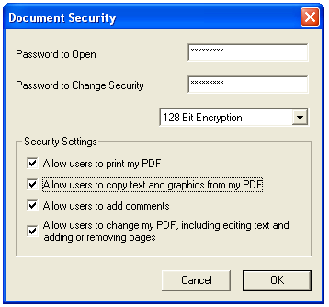

PrimoPDF is quick and easy to install and use. Once installed, the option to print to a PrimoPDF file becomes available in the printer selection window of all Windows applications. From a Windows application select File, then Print, then select in the printer name selection box “PrimoPDF”. After clicking on “OK”, the following box appears:

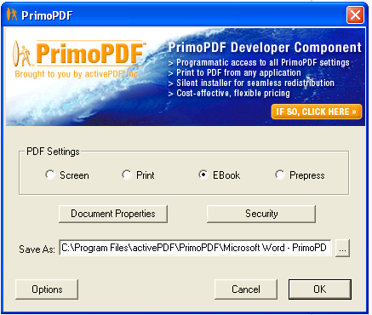

The format of the output file is affected by the PDF setting selections while the Security box allows for the settings as indicated above.

Overall, I recommend PrimoPDF for those that do not require more advanced features. The program does what the authors claim with no errors. I cannot say that Adobe Acrobat is error free. For more complex needs, such as combining PDF files into one document, I recommend PDF Converter Professional 4. For those that do not watch the cash flow closely, Adobe Acrobat 8.0 is the Roll Royce of PDF creators (with some flaws).
If you have any questions or wish to add to the above, please e-mail me at ronmettler@yahoo.com

